Project 2 Report

**Summary**

For this project, I decided to do the first problem “Search and Replacing substring.” I chose it because the instructions were concise and comprehensive. I also feel that the skills necessary to produce this program could be very useful in the future.

The prompt for this project suggests to use “the example in Chapter 13 as the starting point,” presumably from the chapter slides. Chapter 13 gives a good representation of how to understand the concept of a state machine. However, the actual structure of the machine is that of a switch statement, which only accounts for a word of a fixed length. Since the program has to account for query words of varying length, I did not implement a switch statement at all. Instead, I opted for iterating through each letter of the word scanned from the stream, and checked it matched the corresponding letter in the query word.

The input/ output C library (stdio.h) provides to options for scanning a stream of text. You can scan by each individual letter, or scan through each string of letters. I decided to scan through each word, and checked if each letter within that word matched the query. In terms of performance, it may have been more efficient to scan letter-by-letter but since the instructions do not specify any performance standards, I went with the more comprehensive approach of scanning word-by-word.

The state machine in my program would have looked like this:

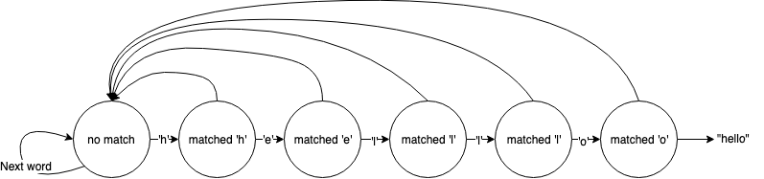

Not matching the letter simply skips to the next word in the stream.

Lastly, I had an issue with trying to edit the text file through the program. Directly editing the file proved to be too difficult since I could not find a way to properly control the position of the stream. To get around this, I decided to create a temporary text file which would receive all the text from the stream except for the query words (with the replacement words in their place). Again, this may not have been the most efficient way to complete the task, but it accomplished the objective nonetheless.

**Flowchart**

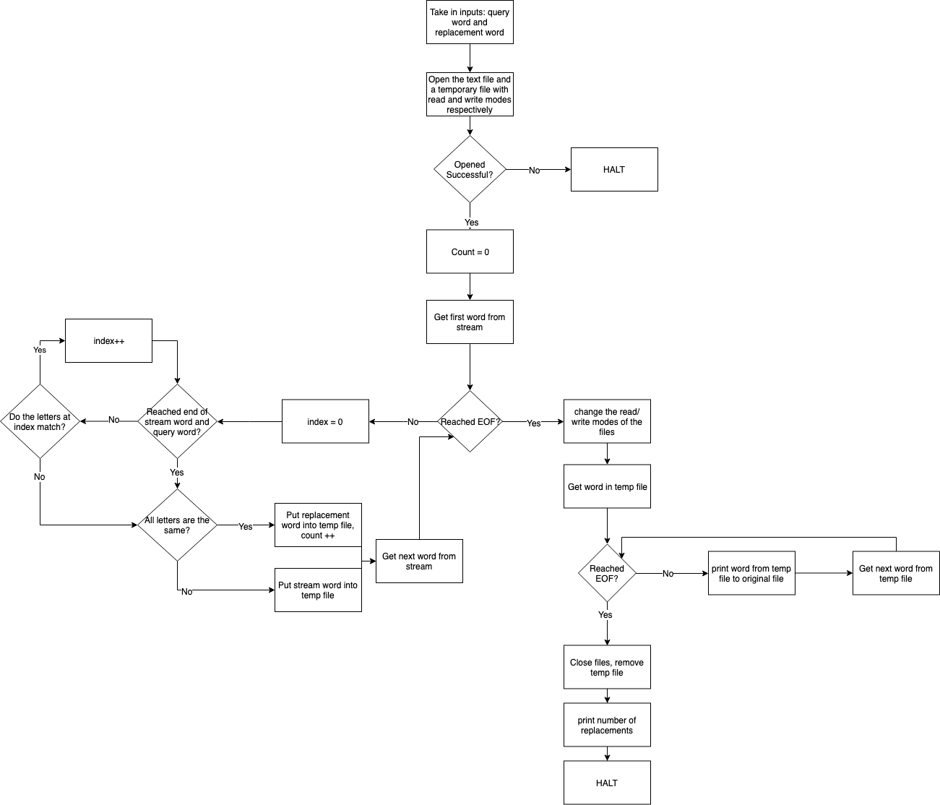

Screenshots are in the folder.